

**REPORT FOR CHATBOT**

**As a project for Course**

**ARTIFICIAL INTELLIGENCE(INT404)**

PROJECT TITLE: CHATBOT

Name: G. Karthik

Reg No: 11801916

Program: B . tech(CSE)

Semester: 4

School: School of Computer Science and Engineering(SCSE)

Roll No: 51

Section: K18JC (Group 2)

Name of University: Lovely Professional University

Date of Submission: 28th March 2020

Submitted to: Sagar Pande sir.

Table of Contents

1. ABSTRACT 2
2. INTRODUCTION 2 – 3
   1. Aim
   2. Motivation
   3. Context
3. Conceptual Framework 3 - 5
   1. Libraries used and explanation
   2. Advantages of Chatbots
4. Scope of the Project 5 - 6
5. Screenshots 6 - 7
6. Working 7 - 9
7. References 9 - 10
8. Conclusion 9 - 10

**CHATBOT**

**ABSTRACT:-**

Now a days many business and online applications are requiring high necessary of monitoring the services through their applications which needs a lot of communication with customers to resolve their queries and assist them for this chatbots became the solutions to assist the customers 24 x 7.

**ACKNOWLEDGEMENT:-**

I would like to thank my mentor Prof. Sagar Pande for his advice and inputs on this project. May thanks to my friends as well, who spent their valuable time to listen and provide feedback.

**INTRODUCTION:**

Aim:

To create a simple AI chatbot which is used to interact with the user on basis of user inputs.

Motivation:

I chose to do this project because I’m in very much excited and interested that how basically the back end of the chatbot works as we know on the basis user inputs that how front end will gives the reply to the user very fastly. So, I wanted to work upon the backend and to create an simple AI chatbot. Since I’m beginner I wanted to be it simple.

Context:

A chatbot is an intelligent system of software that is capable of communicating and performing actions similar to a human. Chatbots are used a lot in customer interaction, marketing on social network sites and instantly messaging the client so as to keep track of their products feedback, to improve the services, also solve the customer interactions in an easy manner.

Basically, there are two different types of chatbot models on basis of how they are built; Retrieval based and Generative based models.

There are 2 types of chatbots:

1. Retrieval based chatbots :

In this type of chatbots responses are predefined, which means on the basis of user message replies are predefined as which is used to display.

1. Generative based chatbots :

In this type of chatbots responses are not predefined, instead they are trained using a large number of previous conversations, based upon which responses to the user are generated.

They require a very large amount of conversational data to train.

**Conceptual framework:**

Library used:

1)NTLK(Natural Language tool kit)

And imported 2 classes. They are Chat, reflections.

NLTK : It is a suite of libraries and programs for symbolic and statistical natural language processing (NLP) for English written in the Python programming language. It was developed by Steven Bird and Edward Loper in the Department of Computer and Information Science at the University of Pennsylvania.

Chat: This is a class that has all the logic that is used by the chatbot.

Reflections: This is a dictionary that contains a set of input values and its corresponding output values. It is an optional dictionary that we can use. We can also create our own dictionary in the same format as below and use it in our code. If we check nltk.chat.util, we can see its values as below:

Reflections = {

‘ i ’: ‘ you ’ ,

‘ i am ’ : ‘ you are’ ,

‘ i was ’ : ‘ you were’ ,

“i'm" : ‘ you are ’ ,

"i'd" : ‘ you would ‘ ,

“i’ll” : ‘ you will ‘ ,

“ i’m ”: ’ you are ’,

"you'll" : "I will",

“ you ‘ve ” : ‘ I have ’ ,

‘ your ‘ : ‘ my ’,

‘ yours ‘ : ‘ mine ’,

‘ you were ‘ : ‘ I was ‘ ,

‘ you ‘ : ‘ me ‘,

‘ me ‘ : ‘ you ‘,

‘ you are ‘ : ‘ I am ‘ ,

}

• I also created one dummy reflection class which give the reflection on the basis of user defined actions.

my­_dummy_reflections = +{

‘ go ’ : ‘ gone ’ ,

‘ hello ’ : ‘ hey there ’

}

• we will train our chatbot using patterns like :

pairs = [

[‘ my name is (.*) ’, [‘ hi %1’]],

]

On the basis of the patterns we are designed the chatbot, it can able to detect the pattern and the response as the reflections are defined.

• In this project I am building retrieval based chatbot so, it only gives the response.it doesn’t do any actions.

Advantages for using chatbots:

1. Increase customer engagement

2. Available round the clock

3. Improves customer satisfaction

4. Feedback of an organisation for improving organization or their products.

**Scope of the Project**

Milestones:

13/02/2020 -- Learning about Chatbots.

15/02/2020 – Applications, Advantage and dis-advantges of Chatbots.

20/02/2020 – Research about the libraries required to implement for Chatbot.

05/03/2020 – Setting the code.

11/03/2020 – Testing the code.

19/03/2020 – Rechecking and adding details to the code.

21/03/2020 – Code is completed(code is fully functional).

**Screenshots:-**

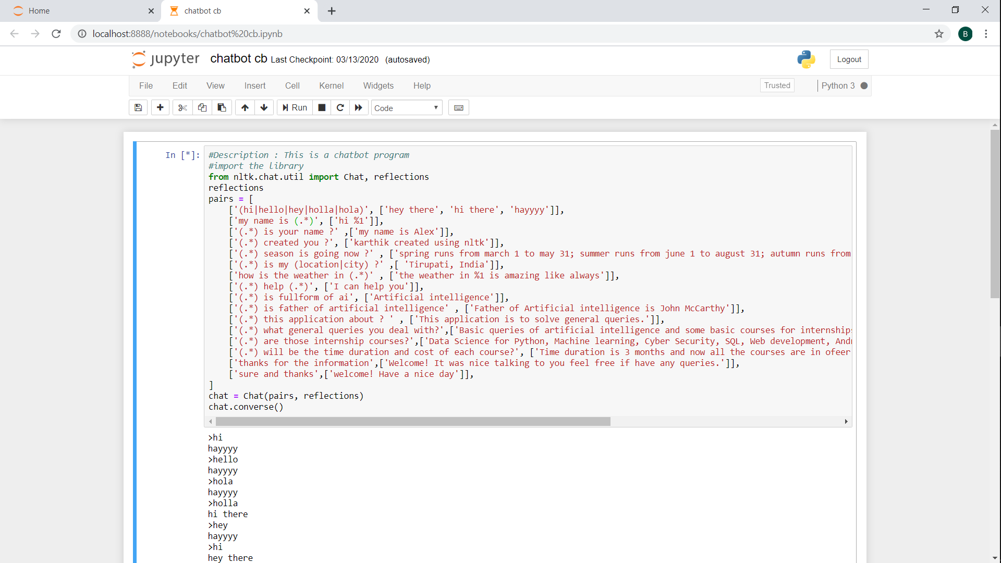

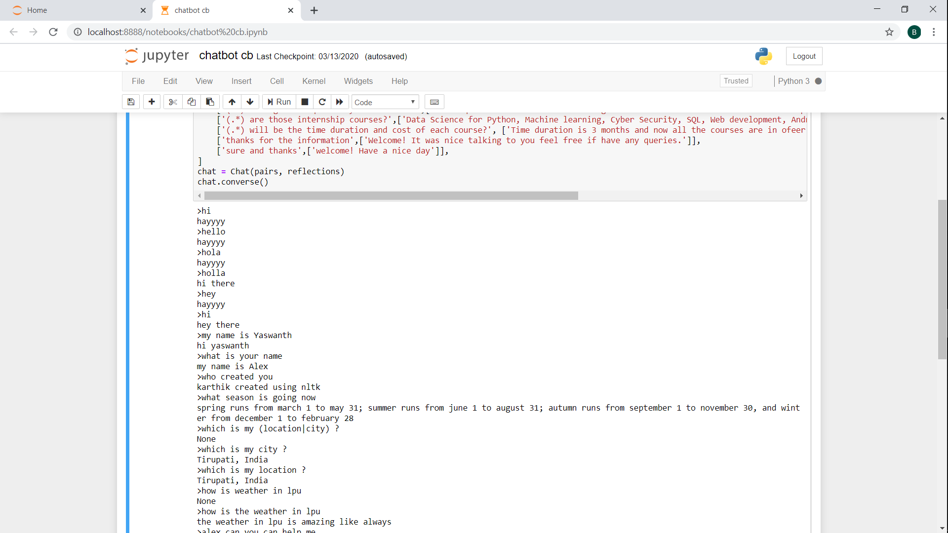

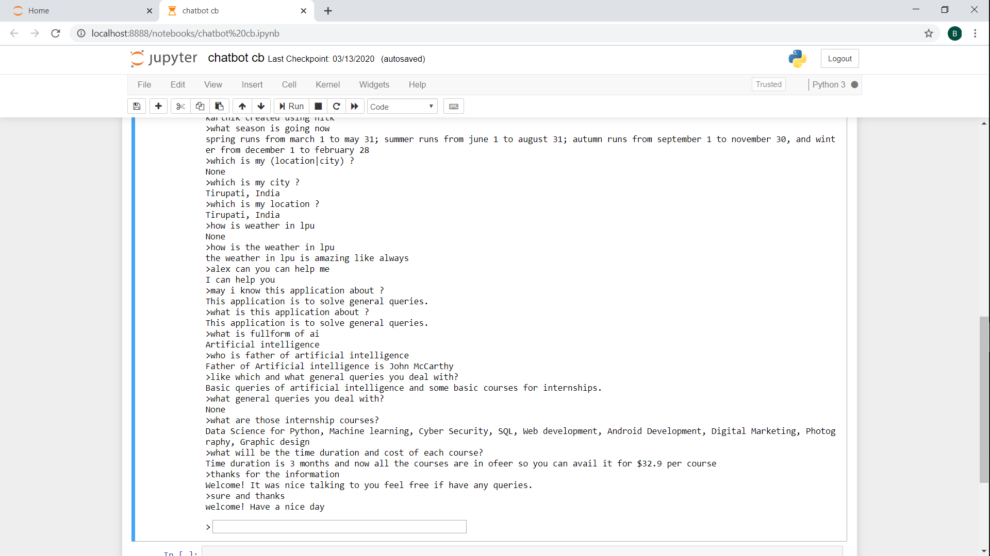

**Working:**

In this project I’m doing the retrieval based chatbot so, the should be predefined to have the outputs for same. From above Screenshots we can clearly see the outputs based on the given inputs for example: input given is hi output is hey there.

Here, after clicking on run we will encounter with a text box as we can see in the last screenshot in that box we need to enter the predefined inputs which are already defined in the code for that the output of code is resulted which is coded in the code like as follows

>hi

hayyyy

>hello

hayyyy

>hola

hayyyy

>holla

hi there

>hey

hayyyy

>hi

hey there

>my name is Yaswanth

hi yaswanth

>what is your name

my name is Alex

>who created you

karthik created using nltk

>what season is going now

spring runs from march 1 to may 31; summer runs from june 1 to august 31; autumn runs from september 1 to november 30, and winter from december 1 to february 28

>which is my (location|city) ?

None

>which is my city ?

Tirupati, India

>which is my location ?

Tirupati, India

>how is weather in lpu

None

>how is the weather in lpu

the weather in lpu is amazing like always

>alex can you can help me

I can help you

>may i know this application about ?

This application is to solve general queries.

>what is this application about ?

This application is to solve general queries.

>what is fullform of ai

Artificial intelligence

>who is father of artificial intelligence

Father of Artificial intelligence is John McCarthy

>like which and what general queries you deal with?

Basic queries of artificial intelligence and some basic courses for internships.

>what general queries you deal with?

None

>what are those internship courses?

Data Science for Python, Machine learning, Cyber Security, SQL, Web development, Android Development, Digital Marketing, Photography, Graphic design

>what will be the time duration and cost of each course?

Time duration is 3 months and now all the courses are in ofeer so you can avail it for $32.9 per course

>thanks for the information

Welcome! It was nice talking to you feel free if have any queries.

>sure and thanks

welcome! Have a nice day

In the context we can see that >……… are the input from user and the output is followed to it. And in the code (.*) it refers to the question

Or input given wish to user to enter like who what which etc., it’s user wish.

We can observe some changes given in input results in output like

>which is my city ?

Tirupati, India

>which is my location ?

Tirupati, India

Here for both location and city for anything the output is common.

>like which and what general queries you deal with?

Basic queries of artificial intelligence and some basic courses for internships.

>what general queries you deal with?

None

And here this (.*) is given in code in place of input it is written as like which is used accordingly the predefined output is generated. If it is not used then it is given output as None.

Also based on the reflections output is generated for I am in input gives you are like so on which can be seen in below snapshot. Or mentioned in context under introduction.

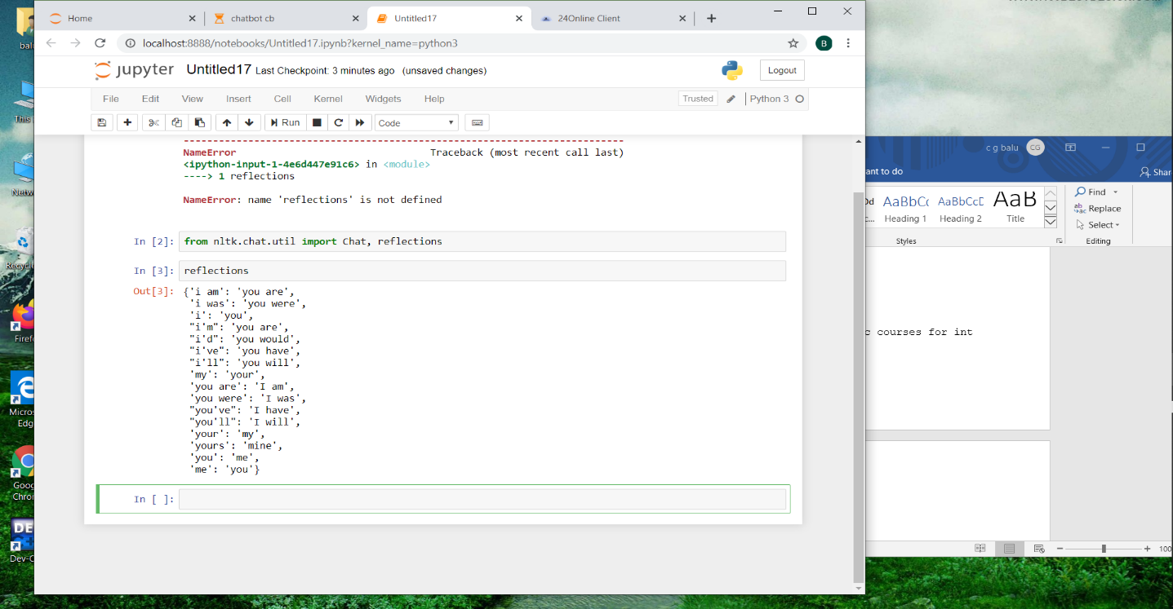

In this project Chat and reflections are two necessary libraries required from nltk(Natural Language Toolkit) and by using the function called chat.converse() we are getting the predefined outputs for the input from user by using Chat and reflections libraries.

**References:**

* I have researched about Chatbot from Google.
* I researched and learnt the libraries required for it from You Tube.

**Conclusion:**

The chatbot can able to response everything until it can able to match the pattern. So, we need to train the chatbot in many patterns.